**Universität zu Köln**

Philosophische Fakultät

Archäologisches Institut

****Sommersemester 2023

Modulprüfung: 3D Modelling

Creating a 3D Model of an Aqueduct Bridge in Cinema4d

Prüfer: Dr. Sebastian Hageneuer

Lorenzo Canals

Hahnenstraße 17

50354 Hürth

Tel.: 017693255736

[lcanals@smail.uni-koeln.de](mailto:lcanals@smail.uni-koeln.de)

[l.canals73@gmail.com](mailto:l.canals73@gmail.com)

Köln, den 15.03.20

Considerations on Ethics and Theory of 3D Reconstruction

We could just start sculpting around and create purely fictional pillars, arches and so forth and make it look like one of the famous aqueducts bridges. Because the given task does not specify what kind of aqueduct is wanted, not even that it should be supported by a bridge with supporting arches. But if this model gets 3D printed and will sit in the collection of an institute, possibly for decades, information will get lost over time and there is a chance that either nobody will understand the identity of the building or worse, may take it as an authentic reconstruction of an actual building. The purpose of the 3D print beyond being part of a collection, should be specified. The theoretical and ethical Implications of 3D reconstruction have been discussed extensively and for decades in academic research, so it is difficult to point to specific publications. Most notable are “The Sevilla Principles” and the “London Charter for computer-based visualisation of cultural heritage”, because they represent the resulting and universally applicable guidelines (despite their age) for 3D reconstructions in Archaeology. Following are some brief explanations of some typical, theoretical and ethical implications, based on those. It’s noteworthy that these often apply to all kinds of reconstructions, not just virtual 3D models.

Theoretical implications:

Interpretation Bias: reconstructions in archaeology of any kind, involve interpretation of archaeological “features”, meaning the underlying data is always fragmented or incomplete. There is always a human who has to filter and fill in the gaps. Since humans usually have different kinds of biases, of which they may not even be aware, this predicament may lead to biases in the final representation of ancient structures or artifacts. In this project, I just assumed that the green long block expected me to model an aqueduct bridge, so my vision was indeed biased to begin with.

We see that a lot in physical reconstructions in ancient roman sites. In the last century, the advent of tourism, a better understanding of ancient architecture and concrete as a versatile, cheap and strong building material inspired the imagination and lust for reconstructing monumental roman architecture. One such example could be the Nymphaeum Traiani in Ephesus. It was “reconstructed” despite a lot of its superstructure is missing and not even to the correct height, producing a sorry image of confusing dimensions. Adding pain to injury, the concrete is not that easy to remove and changes are therefore hardly possible. This point leads into the next implication:

Accuracy vs. Speculation: Every reconstruction needs to find a balance between accuracy and the inevitable speculation involved in filling gaps in the archaeological record. This may raise questions about the validity and reliability of reconstructions. In this project, I used a schematic plan of the layers of lime slabs as the main source for my model. It does not show any kind of detail (like decorations) or true to life variations. However, this aqueduct bridge is designed and constructed very uniformly with little to no decorations, as far as I’m aware. So, I would argue that accuracy and speculation are actually well balanced.

Temporal Validity: As time passes and more research is conducted, the underlying archaeological record and conclusion can change. Earlier reconstructions are rendered obsolete or inaccurate.

Ethical Implications:

Authenticity of Representations and Ownership of Cultural Heritage:

Ethical concerns may arise about the credibility of reconstructions when compared the original sites, as well as their portrayal of ancient cultures and peoples. For example, in my 3D model of the Puente del Diablo, I used plans to model (‘sculpt’ would also be fitting), an aqueduct bridge that crossed a valley. This valley, however, did never contain a river like the reference terrain model did (as far as I’m aware). Also note how architectonical features of pillars sitting in rivers are missing. This aqueduct bridge couldn’t exist in reality. But it may look convincing to someone. My ‘reconstruction’ took a real building of a different nations cultural heritage and misplaced it, in what looks like a terrain of a real site. Collaboration with stakeholders would improve this situation. Perhaps they could provide more accurate data than is available online. The Institute of Archaeology of the University of Cambridge should be contacted and asked for the purpose of the reconstruction. The “student collection” implies education but what can a 3D print show, that can’t be seen in images?

Presenting 3D Reconstructions and 3D Prints:

Transparency and Communication:

With the established implications above and the scope of this fictional project in mind, transparency is of critical importance. It needs to be stated in some way or form, what the purpose of the model is and how it deviates from reality. As a first step, I would recommend a good label somewhere on the print, with key information. It should already point to the fictive nature. Then, for a presumed database of the collection, a short info text should be delivered, which summarizes the project and contains links to access the full documentation and files online.

Label example:

Fictional 3D Model of an Aqueduct Bridge

Bridge is based on “Puente del Diablo”, Tarragona, Spain

Fictional location

Made by: Lorenzo Canals in 2024

Address, Contact info, Etc.

Documentation:

Firstly, the documentation should be accessible online. It should be comprehensive, equipped with sources, methodologies, and assumptions underlying the reconstruction. This is for the purpose of verification by other scholars. Secondly, some contextualization would be helpful, like the real localization of the terrain model and the real location of the bridge, along with photographic evidence. Some of which is provided in this documentation.

Reconstruction process

1.Reference Material and initial Considerations

Since the target audience is in the field of academics and the purpose is somewhat educational, it makes sense to attempt to balance the “Accuracy vs. Speculation” scale more in favor of accuracy. Higher accuracy comes at a cost of efficiency[1] though and time was under one week for this exam.

The reference model implies that the aqueduct is supposed to bridge over a valley and optionally a river or ancient river bed. “Optionally” because despite the image we typically have of an aqueduct in our mind, not all of them cross rivers and wide valleys. Essentially, an aqueduct is a water pipe and only in special cases were bridges constructed. But I assumed that this is the expected model architecture. The easiest way to get a list of candidates quickly, is the “List of Aqueducts in the Roman Empire”[2] on Wikipedia. Based on those requirements and the seemingly large scale and expected size of the 3D print, two specific aqueduct bridges come to mind:

First the Pont du Gard in France, which is probably the most iconic roman aqueduct. It’s also known to be the tallest and among the best preserved. It was built in the 1st century AD, crosses a river and has very wide and near circular arches, of various positions and dimensions, meaning it requires a lot of handwork in modelling. So, I decided against it.

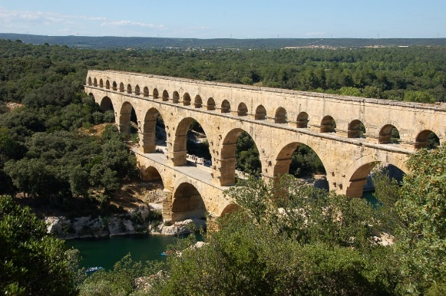[3]

My second option is found in Spain and called the Aqüeducte de les Ferreres, or Pont del Diable (Catalan). It is one of the most famous *arcuationes* (latin name for this kind of bridge) in all of Spain and was built in Augustean times.[4] The architectural design is overall very uniform and the construction style is referred to as *opus quadratum*. That should make modelling easier.

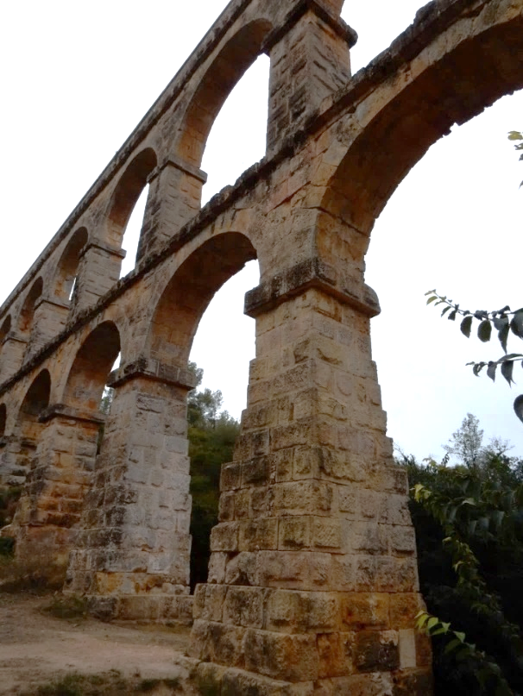[5]

It crosses a dry valley, meaning the pillars are set on the ground and rectangular in shape, unlike river crossing bridges, that (sometimes) appear with wedge-shaped piers, like for example the Ponte Sant’ Angelo in Rome. Furthermore, the bridge has what I call a double gallery in the center and single gallery at maximum height besides it.

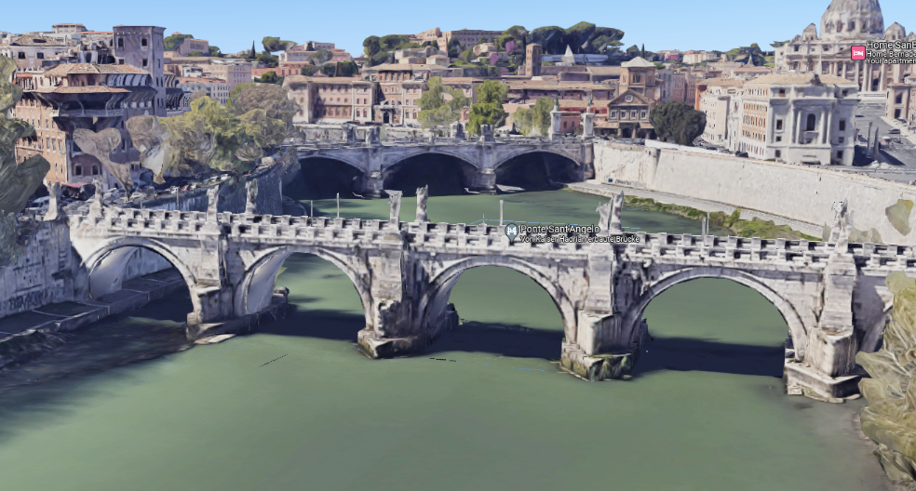[6]

2. Distortion and scaling of the reference material

There aren’t many elevation or section plans published for this aqueduct bridge and after my initial research, it seems there currently exists no really accurate or recent stone-true plan. Instead, the archaeological literature did what happens all too often. It copies, scales and reprints old plans (doing all that in the pre-digital era), resulting in some amount of distortion. Also, old plans are typically hand drawn and based on hand measures, so anything outside of an actual “Steinplan” could be considered a somewhat scaled sketch. In the referred publication[7] it seems like the old French plan (“alzado y planta”)[8] has some compression in the height axis, which could also be a product of me scanning the paper pages. It also fails to represent the steps in the pillar. This can be seen much better in the authors 2D plan (“detalles de la estructura en alzado y seccion vertical”), which respects the roman units and appears to be scaled more correctly. Therefore, the old French depiction is from here on considered as less accurate and is only good for estimating the scale of the pillars besides the double gallery in the center. In the end, I scaled the spanish schematic based on pillar width and height of the lower gallery, and assumed, that ‘roundness’ and radius of the arches are more correctly reproduced here.

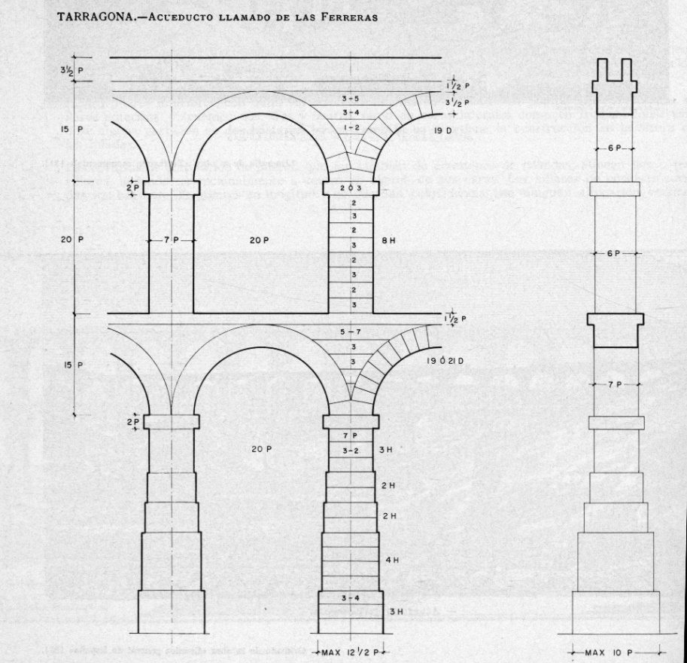

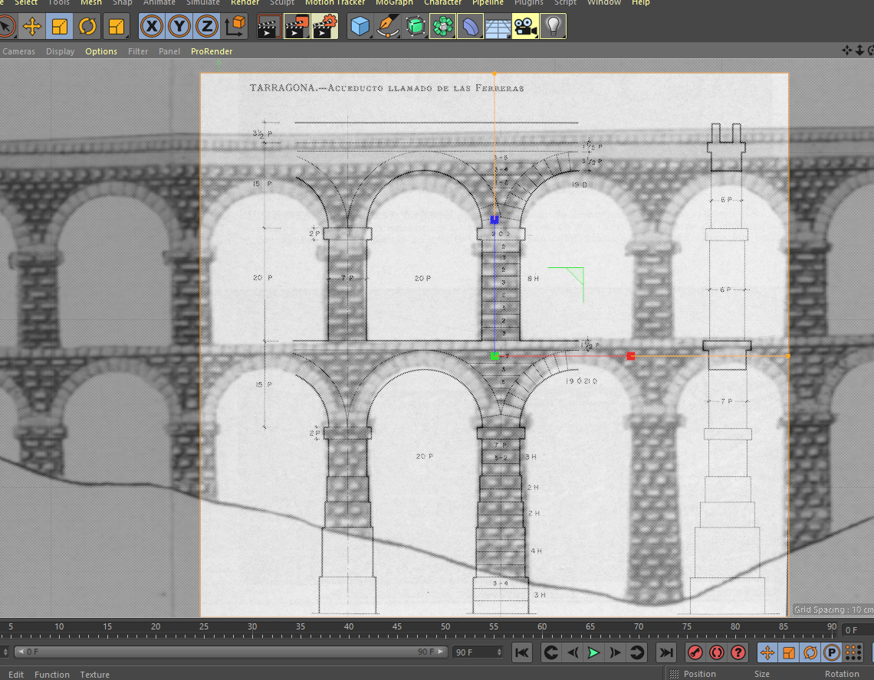

3. The modelling approach and considerations on 3D Printing

A choice that presents itself once the reference images are done and also in general, is whether to use box or spline modelling. In my opinion, the spline can create more complex shapes when modelling based on 2D images but increases the handy work when dealing with simple geometries, like the rectangular ashlars found here.

Thanks to the overall uniformity, symmetry and lack of serious architectural decorations (which seems unsurprising on a utility building outside of urban spaces), box modelling seems to be the better approach, at least for the pillars. The surfaces of cubes can be easily extruded and stretched to match the existing plans, while providing more uniformity and simplicity than spline modelling could in the same amount of time. With a few boxes a bottom pillar is quickly done. The layers seen in the background image represent the actual block height and indicates how many blocks were used per layer.

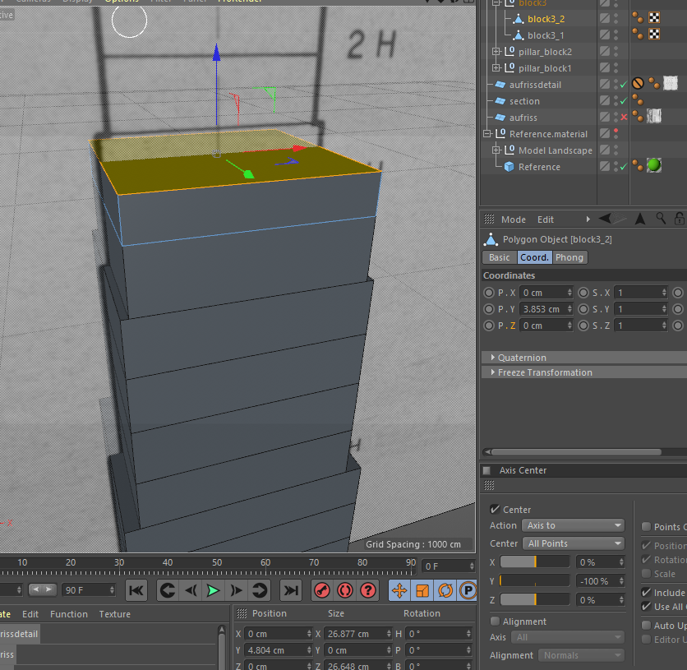

Noteworthy is the use of snapping to assure that the individual blocks are actually touching each other, or else the 3D print may run into issues. From my experience I’d expect errors like layer shifts or bad layer adhesion, resulting in a failed print. This is very frustrating as such small oversights are time consuming to fix afterwards. Furthermore, the use of box modelling and the relative simplicity helps with avoiding mesh holes (in my experience), which confuse slicer programs and will create unusable gcode.

One more question that arises from the use of such a standardized schematic plan is the possible lack of ‘realism’, or rather it misses certain details like architectonical decorations (ornaments, beveling, irregularities, etc.) that make it feel believable and alive. The resulting boxes may even look too simplistic. I would argue, that since the archaeological documentation does not reliably record any of that, e. g. in form of a LIDAR, or SFM generated point cloud, we could only hope to ‘fictionalize’ (aka fake) the missing details. One fix to this could be the recreation of the bossage visible on photos (see above). If I can come up with an efficient way to do this later on, I will report on that. However, what already can be said is that Bossage does not appear on every block and it’s generally debatable when it is a style element and when it is simply a sign of unfinished work. The arches (photo) appear with their bossage removed. It will need extra consideration and explanation why and where bossage was recreated, when it isn’t even well documented. In the photo below, we can even see various stages of how much of the bossage was removed.

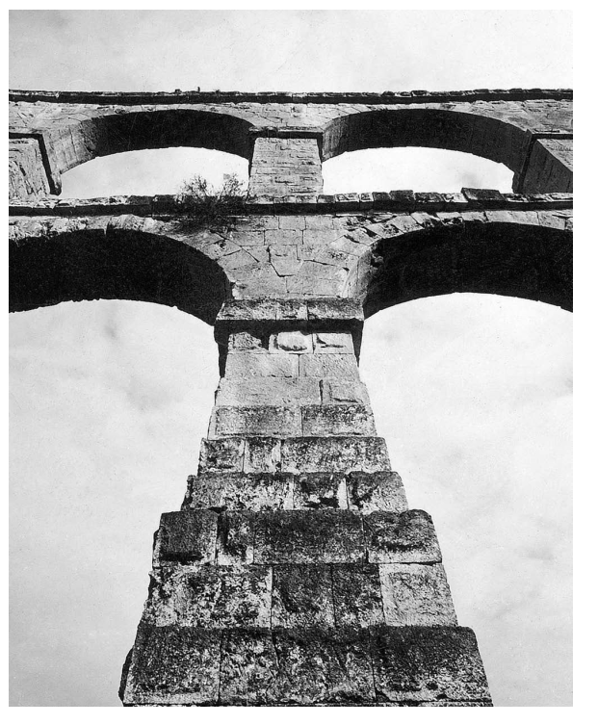[9]

From the perspective of 3D printing, it depends on the print scale and the purpose of the model. If I create bossage and the model will be printed at a small scale, they may not even appear because they disappear between layer heights and my even introduce other issues like stringing, at least in my experience with cheap FDM printers. Also, if the purpose is to show students what bossage looks like, I believe a separate model based on, for example, an SFM point cloud, of a section of a single pillar, printed on a larger scale, would make far more sense. In that scenario the purpose would be teaching of architectural details. I would assume the model only serves to visualize the main components of an aqueduct bridge.

4. Modelling the Center Gallery

The pillar width is also easy to model, since the plan provides both front and sides. Thanks to that an the remarks in the text, I understand the alternation of the ashlar layers. If one layer, seen frontally has only tow blocks, the next one above will have three. Same on the sides. This prevents continuous vertical gaps. On the photos we can easily see, that albeit the layer height is uniform, the block width is pretty random. So I just used the tool ‘plane cut’ to slice the surface polygons of the boxes randomly, by hand. This menu can be be opened by a right clicke. There I also found the function ‘inner extrude’. This slices surfaces inside and creates a look similar to a painting frame, or inversely, a bossage. With multiple surfaces selected simultaneously, this was very efficiently done (screenshot below). The dimensions were pure guesses but still look quite convincing. I varied the offset of the bossage top surface from cube to cube so they don’t look too similar, just like in real life.

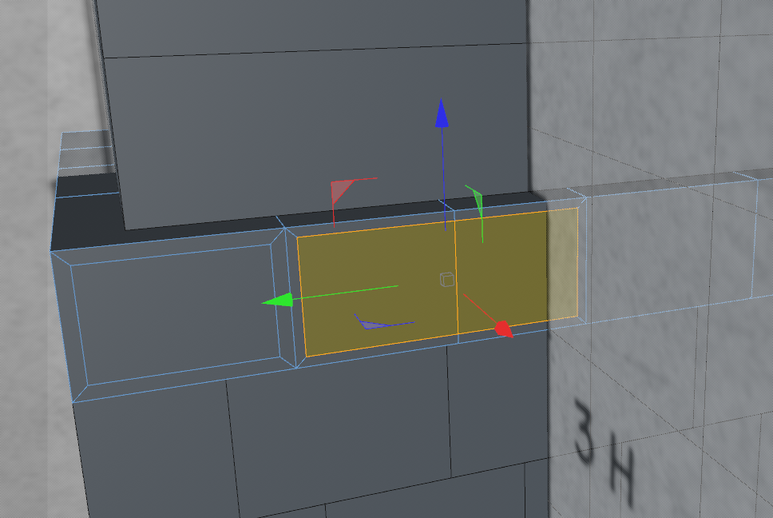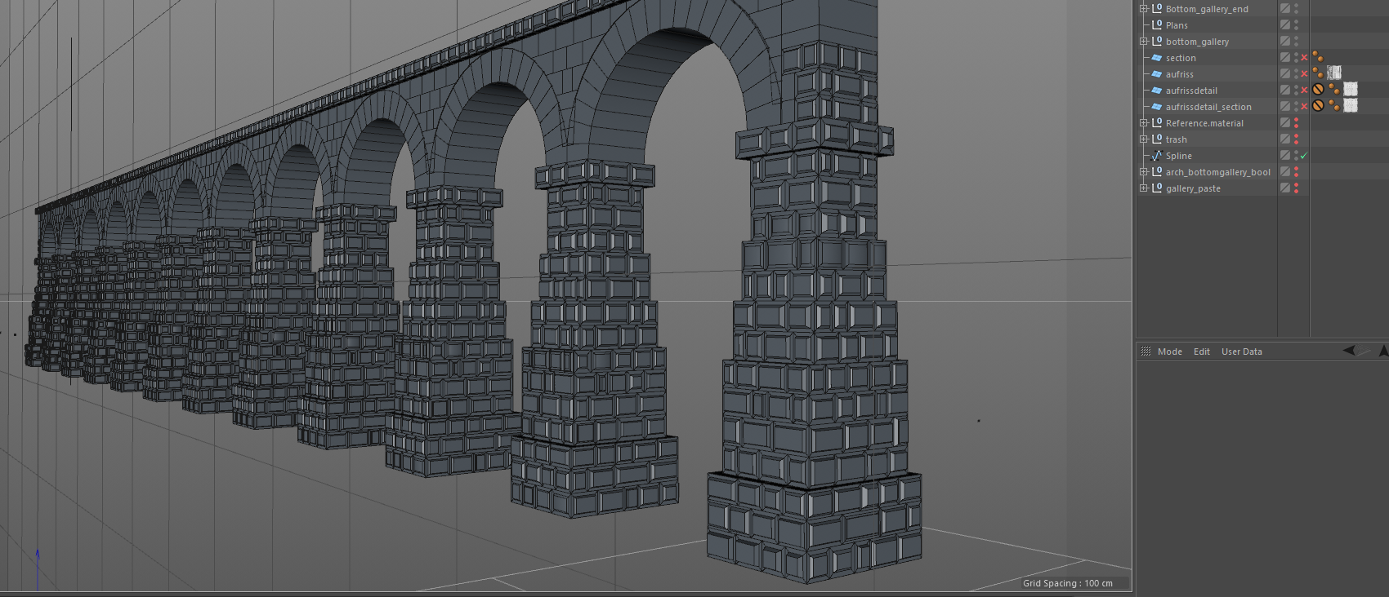

For the arches I decided to create two cyclinders with the correct number of segments (40 for the whole circle, 10 for each quarter) and an estimated radius by laying it over the plan. With a Bool object, the inner cylinder subtracted from the outer cylinder and created a tube. This tube only needed to be cut and the surfaces adjusted to better meet the blocks as they appear on the plans and in photos.

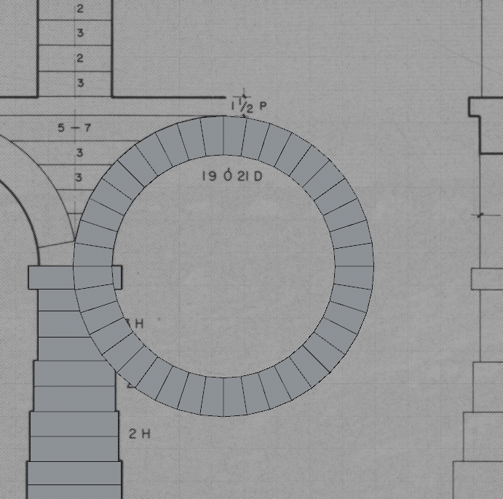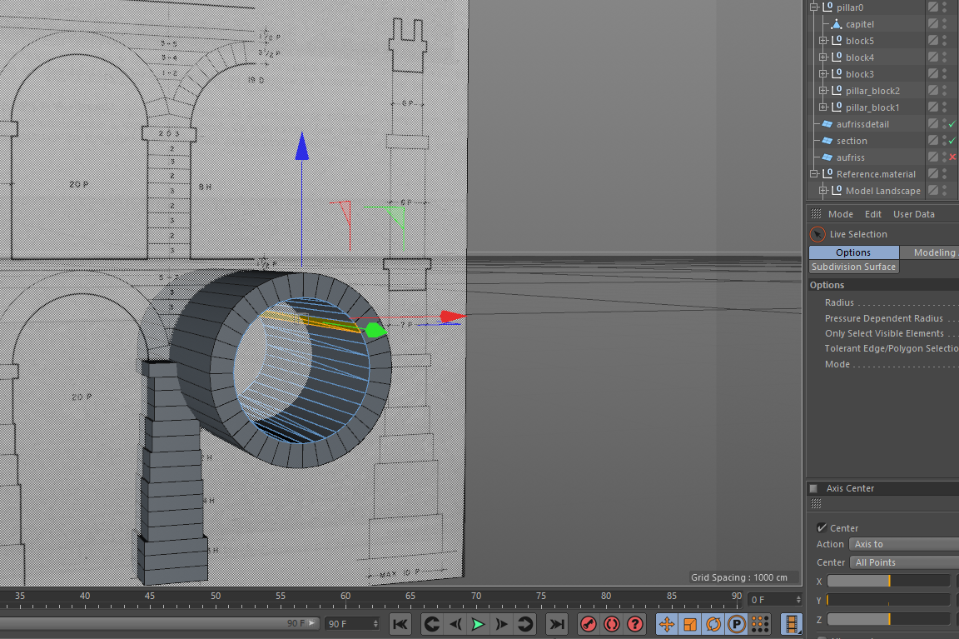

The filling material between arches was first created as simple cubes, with the intent of using another bool object to simply subtract the arch from those cubes but that didn’t work very well and I’m not quite sure why, so that’s why there are these seemingly out of place double lines where arches meet. The number of capstones per arch I counted from photos.

The Center-Top-Gallery was done in very much the same fashion, except I paid more attention to the filler material in between archer and extruded surfaces more carefully, so that the follow the shape of the arches exactly. Noteworthy is how the two second arch blocks are larger and meet in the center. No plans accurately reproduced this, so I guessed based on photos. [10]

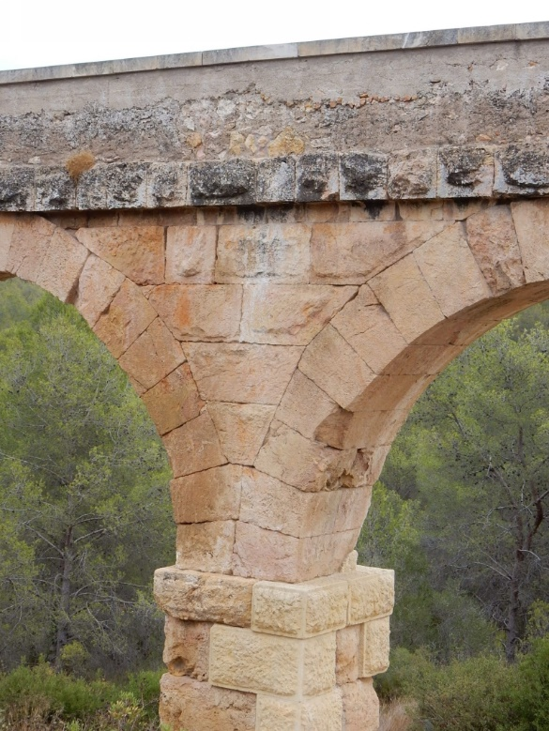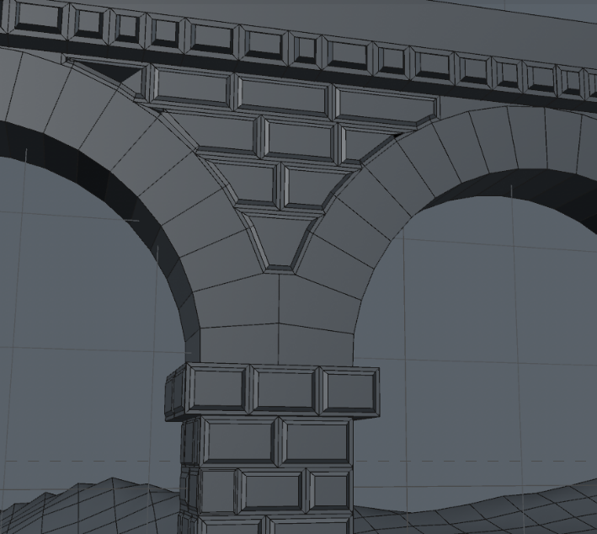

Note how the bossage is generally less elevated in this area. This has been respected.

5. The Side-Galleries

The parts beside the double stacked gallery are referred to as side galleries. The arches here are simple continuation of the same arches found in the top gallery and didn’t need to be modelled again. Or rather, this was my assumption because the publication did not include separate plans.[11] Counting the number of stones on the pixelated photos gave further reason to accept this assumption. For the long pillar I could find neither accurate plans[12] nor good photos, so I simply reused bottom and top pillars and filled the missing section with more cubes form the top pillar. This way, a plausible uniformity is maintained. The available photos show the side-gallery pillars to be in the soil, already at the level of the capstone of the bottom gallery

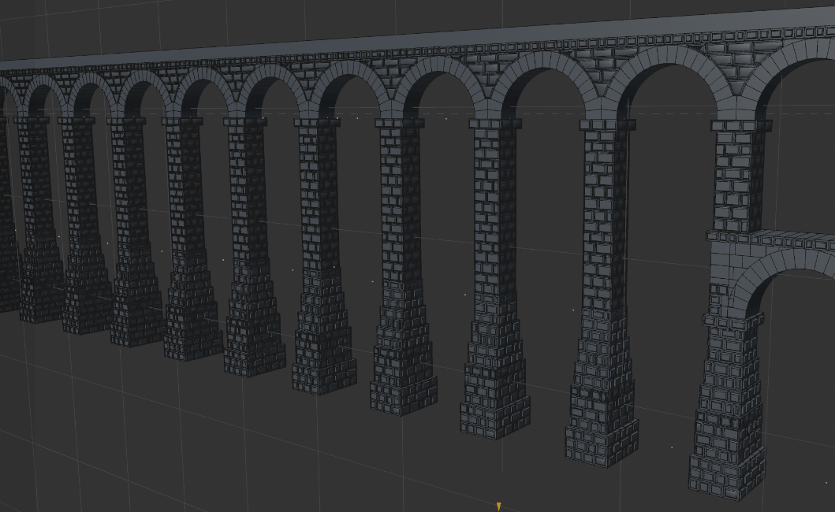

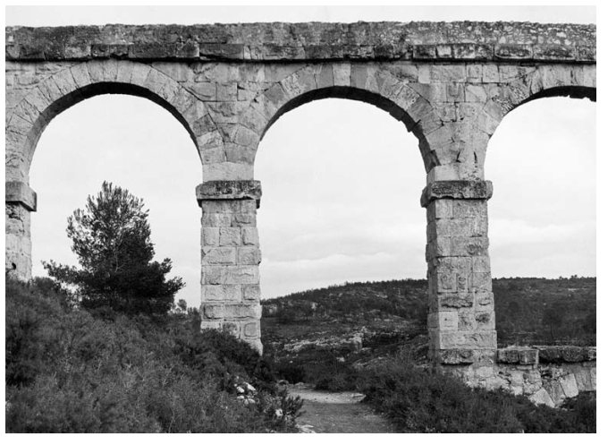[13]

6. Cutting the Model, Positioning in the Terrain

Originally, I modelled the entire length of the bridge. Soon I realized though, it wouldn’t fit entirely into the given reference terrain model because of its length. So, I had to cut some arches off. Also, I felt like the double gallery should be over the lowest part of the valley, as it is in real life. To cut the model I simply created vertical planes on the sides off the reference model, then closed the holes.

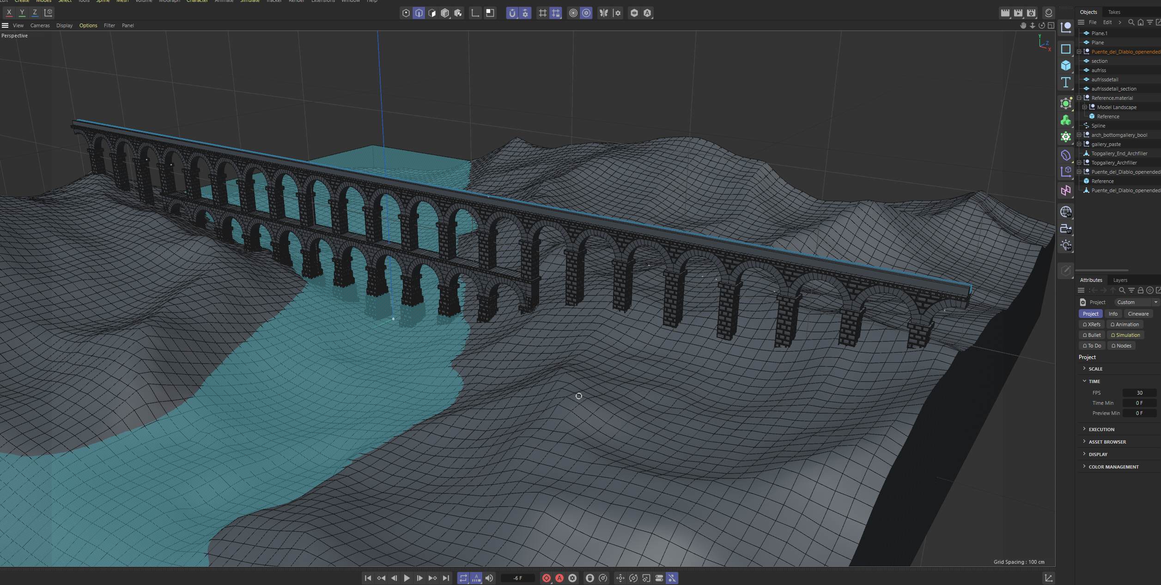

7.Textures and Renders

At this point of the module exam I was very much out of time, so, a quick and efficient solution was needed for the textures. I could not find in the literature the exact building material, but I believe it to be limestone. It is a very porous stone and appears on photos with a sandy to orange or ochre color tone. I used the only limestone material Cinema4d had to offer and changed the color a bit towards orange.

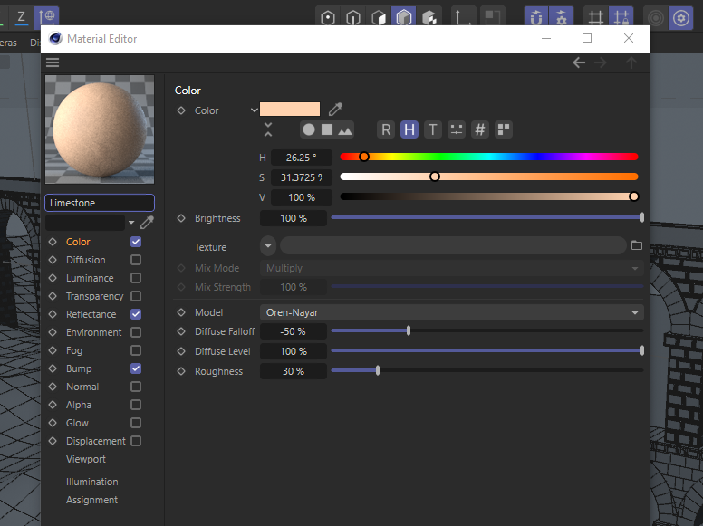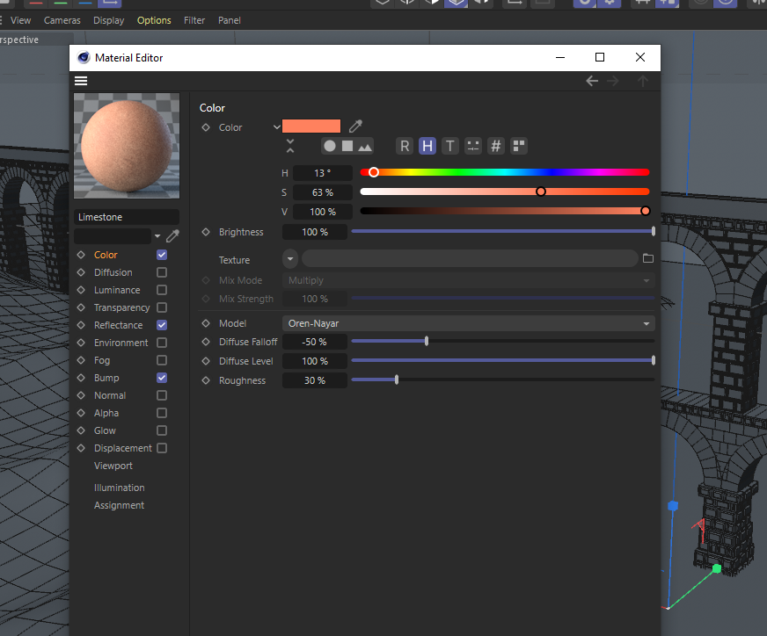

Finally I added a ‘physical sky’ and let the program make some renders, with the settings from the tutrials.

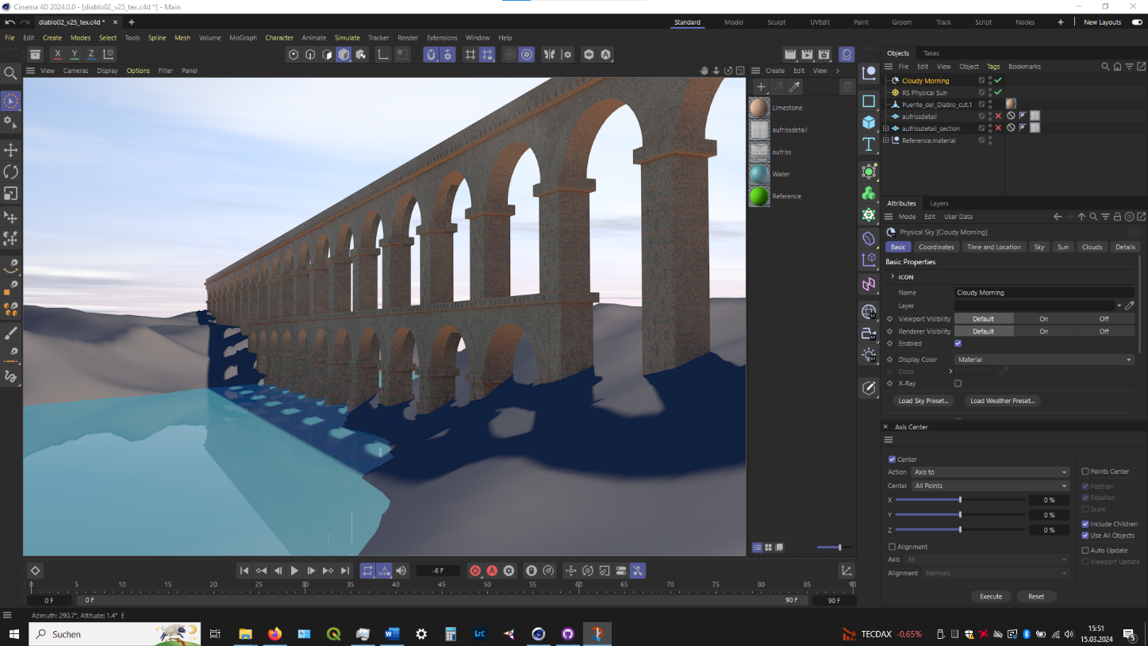

8. Acknowledgement of Flaws

Even though this *arcuatio* is probably not suited to stand in water, at least it respects terrain elevation. This realization came to me actually only at the point of positioning the model, so I tried to at least explain this issue thoroughly in this report. Also the scaling is in the end purely eyeballed.

Another such potentially fatal realization is the fact that the Spanish literature actually describes the arches of the top gallery to be made of 8 blocks per half-arch plus a keystone, but because of time constraints and language barrier I missed that in my earlier research and couldn’t fix this in time.

Same probably applies to the building material. I couldn’t find it in the literature but that was probably because of time and language constraints. This is another example why collaboration with stakeholders would be helpful, because it could have helped me collect more data and reference material.

Considering the theoretical implications mentioned above, the biggest flaw of this model is arguably the lack of clarification, meaning it is not obvious from the 3D model which parts are original, speculative, reconstructed or repaired in later times or even missing entirely. For example, the archaeological research has found the inclination of this aqueduct,[14] but it’s not included in this model. The design and cover of the water channel were not considered either. But on the other hand, if the purpose wasn’t specified to begin with, how can you make the perfect 3D model?

Literature & Sources

Archaeological Publications

C. F. Casado, Acueductos romanos en Espana (Madrid 2008)

E. Sanchez Lopez–J. Matinez Jimenez, Los Acuedductos de Hispania. Construccion y abandono (Madrid 2016)

Online Sources (all last accessed at 15.03.2024)

Roman Aqueducts Website

http://www.romanaqueducts.info

Wikipedia List of Roman Aqueducts

https://en.wikipedia.org/wiki/List_of_aqueducts_in_the_Roman_Empire

Pont du Gard Photo

https://upload.wikimedia.org/wikipedia/commons/0/02/Pontdugard.jpg

Sevilla Principles

https://www.cipaheritagedocumentation.org/wp-content/uploads/2018/12/L%C3%B3pez-Menchero-Grande-The-principles-of-the-Seville-Charter.pdf

All other screenshots were made by the author.

1. Sevilla Principle 6
2. <https://en.wikipedia.org/wiki/List_of_aqueducts_in_the_Roman_Empire>; see also: http://www.romanaqueducts.info/index.html
3. <https://upload.wikimedia.org/wikipedia/commons/0/02/Pontdugard.jpg>
4. E. Lopez 2016, p. 164-166
5. http://www.romanaqueducts.info/aquasite/tarragona/index.html
6. https://www.google.de/maps/

   @41.9022446,12.467981,33a,35y,246.19h,79.31t/data=!3m1!1e3?hl=de&entry=ttu
7. Casado 2008, p. 29-52
8. Casado 2008, p. 34
9. Casado 2008, p. 15
10. Casado 2008, p. 31 also notes this.
11. As I found out later, it is actually mentioned in the text: Casado 2008, p. 31. More on that below.
12. Closest thing: Casado 2008, p. 31
13. Casado 2008, p. 41
14. 4m/km. E. Lopez 2016, p. 164-166